EDUC 630 – Technology Lesson Demonstration
Canvas Page Template (Student-Facing)
Use this document as a model and planning template for your Technology Lesson Demonstration assignment. Replace all bracketed text with your own content before submitting.

Lesson Overview
Content Area / Grade Level:
World History I – 9th Grade Special Education
Original Lesson Need:
Students were to look back, thinking like archaeologists and paleontologists, at cave art, various fossils, and artifacts from the Neolithic and Paleolithic Ages. After the instruction, students have an application activity to complete, in which they will create their own cave art and draw a picture of what they think homo sapiens/cavemen would have looked like during this time period.
Revised Lesson with Technology Integration:
The lesson remains interactive, and students follow the instructions presented on their school-issued iPads or Chromebooks. Students are to create a Caveman Superhero and design their own cave art backdrop. Students are given a printout to complete their application activity for the day in World History I. The handout has a section for students to scan the QR Code to complete the activity on different applications if they choose not to design their character by drawing.

Lesson Objective
Students will independently use various learning applications and tech tools to complete application/project activities in World History I, demonstrate understanding of early humans' communication, and give students the opportunity to review SOL standards with a modern twist.

Technology Tool Selected
Tool Name:
PowerPoint, Canva, Gemini AI, AI-generated image, FreeForm
Why This Tool Was Chosen:
- Students review digital citizenship at the beginning of the school year
- Students utilize various learning applications to make learning tangible, use their voice, and creativity.
- Students learn responsibility while using the internet and AI tools.
- This tool allows me to differentiate students' activities, learning goals, and make learning fun and equitable for all students.
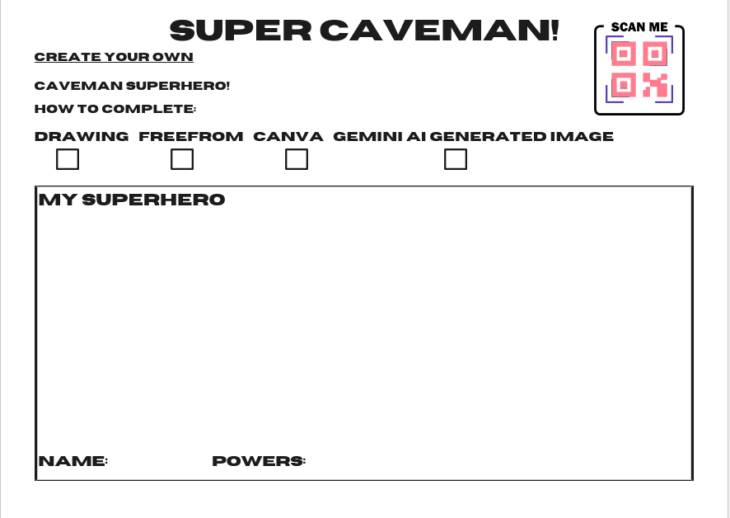
Student Product:
The students who did not freehand a drawing of their Super Caveman used either PowerPoint, Canva, Gemini, or the Freeform app to design their hero. Students who choose to complete the activity digitally will scan the QR code to open the Super Caveman template.

Part 1 – Video Lesson Demonstration
Video Link: https://watch.liberty.edu/media/t/1_rk9718x3
Important: Make sure your video in not set to private. If you use Kaltura, set the publishing status to Unlisted. See How to Publish and Share Videos.

Part 2 – Assessment Rubric
Lesson Objective (repeat here):
Criteria | Exemplary  (4) | Proficient  (3) | Developing  (2) | Beginning  (1) | Not Yet Demonstrated (0) | Points Awarded
Creativity/Uniqueness | 80–100% | 65–79% | 50–64% | 25–49% | Below 25%
Participation | Full – Relevant Information | Mid | Lacks Consistency | Frequently Off-task, minimal | No Applicable
Use of Technology  Prompt | Independent | Gestural | Visual/Verbal | Model | No Applicable
Completion | Full project completed and turned in. | Partially complete or not neat | Attempt with no refusal | Only Picture | No Applicable
Total Points:

Differentiation Plan
My expectations for my students are always high. The classroom where I teach is full of diverse learners with a range of abilities. Students benefit from different learning styles. I have implemented technology for the last 5 years. To differentiate for students to meet their individual needs and IEP goals, and to align with the Virginia state standards. Students, based on their individual abilities and needs, complete assignments in various ways. Some of my students prefer submitting their work in paper form, while my advanced learners prefer uploading their work to Canvas or printing their document and submitting it to the teacher they are working with during the learning period. For students with AAC devices and emergent learners, when completing projects like the Super Caveman design, activities are on paper and supported through teacher modeling and any support the student may need. Digital versions are available to students with the read-aloud accommodation. Students with dyslexia and dyspraxia use speech-to-text to generate ideas and create prompts, and they use AI as a learning tool. The special education classroom is equipped with various technology tools and learning applications that make the learning environment creative and exciting for all diverse learners. It makes learning experiences more differentiated and student-centered.

References

Edwards, S., & Lee, H. (2021). Assistive technology and inclusive practices: Supporting diverse learners in K–12 classrooms. Journal of Special Education Technology, 36(2), 89–104.

